**

**Enterprise Systems Analysis and Design - C#.NET**

**Batch ID: ESAD-CS/NVIT-M/33/02**

**A PROJECT Documentation**

**ON**

**Online Exam System**

**SUBMITTED TO**

**Sayed Zahidul Hassan**

Consultant (.NET),

Show & Tell Consulting Ltd.

**Supervised By**

**Md. Foysal Wahid**

Trainer, New Vision Information Technology Ltd(NVIT)

**SUBMITTED BY**

---------------------------- --------------------------- -----------------------

**Noyem Zahangir Porag Md. Shakil Chowdhury Farjana Yeasmin**

ID: 1237018 ID: 1230120 ID: 1225104

------------------------------ -------------------------------- -----------------------------

**Selina Sultana Syed Md. Abdul Awal Abdul Mazid**

ID: 1237978 ID: 1237014 ID: 1236179

ACKNOWLEDGEMENT

Apart from our efforts, the success of any project depends largely on the encouragement and guidelines of many others. We take this opportunity to express our gratitude to the people who have been influential in the successful completion of this project.

First of all, We would thank the almighty for giving us strength to complete our project on time.

We would like to thank respected **Mr. Sayed Zahidul Hassan**, Consultant (.NET), Show & Tell Consulting Ltd. And **Mr.** **Md. Foysal Wahid,** Trainer, New Vision Information Technology Ltd. for giving us guidelines to complete this project successfully.

Next, We would like to thank my classmates who helped us to make our work more organized and well-stacked till the end.

TABLE OF CONTENT

**CHAPTER -ONE: INTRODUCTION**

**INTRODUCTION** 03

**PURPOSE** 04

**PROJECT PROFILE** 04

**PROPOSED SYSTEM** 05

**OBJECTIVES** 06

**CHAPTER - TWO: METHODOLOGY**

**METHODOLOGY NEEDED** 07

**SOFTWARE DEVELOPMENT LIFE CYCLE** 08

**SOFTWARE PROCESS MODEL** 09

**CHAPTER - THREE: SOFTWARE REQUIREMENT**

**TECHNOLOGY USED** 10

**TABLE DEFINITION** 11

**CHAPTER - FOUR: SOFTWARE DESIGN**

**FULL FLOWCHART** 14

**USECASE** 17

**DATA FLOW DIAGRAM** 18

**CLASS DIAGRAM** 19

**CODESAMPLE…………………………………………………………….……..………………20**

**USERINTERFACESNAPSHOTS………………………………………………………………..22**

**CHAPTER - FIVE: CONCLUSION**

**CONCLUSION ……………………………………………………………………………….…30**

INTRODUCTION





Examination System

Examination is a test not just for the person who gives the exams but also a big test for the management and teacher who arranges the exams. The traditional method of exams involves the paperwork, checking the papers, arranging the marks and then finally feeding the results in computer for printing the reports. Online Examination System removes most the drawback that was in the traditional method. The exams are online, so user can give the exams from anywhere around the world. Also, the exams results can be calculated automatically just at the end of exam. It also minimizes the error in calculating results which humans do most of the time. Also, the most important benefit of making exams online is the data is saved in a structured format which can be used for detail report to make reports, charts and presentation over a period of time. A person can check question paper that was published 10 years ago in an instant.

The purpose of this document is to analyze and elaborate on the high-level needs of the Online Examination System.

PURPOSE

The purpose of the Software Requirements Specification (SRS) is to give a clear and precise description of the functionality of the assessment-support software to be developed and to eliminate ambiguities and misunderstandings that may exist. For the management, the Online Examination System will explain all functions that the system should perform. For the developer, it will be a reference point during system design, implementation and maintenance.

The SRS divides the system requirements into two parts, behavioral and non-behavioral requirements. The behavioral requirements describe the interaction between the System and its environment. Non-behavioral requirements relate to the definition of the attributes of the product as it performs its functions. This includes the level of security, efficiency, reliability, maintainability, portability, capacity, and the standards of compliance of the product. It also describes the design constraints that are to be considered when the system is to be designed, and other factors necessary to provide a complete and comprehensive description of the requirements for the software.

PROJECT PROFILE

**Project definition :** Online Examination System(EXAMROOM_R33).

**Front-End :** Asp.Net Mvc 5, HTML 5, CSS 3, JavaScript.

**Back-end :** C#, SQL Server 2012.

**Type of application :** Web-Based Application.

**Other tools :** Visual Studio 2015, MS Office 2016

**Time duration :**  45 days.

PROPOSED SYSTEM

* The system aims to reduce costs associated with conducting exams over a period of time and achieving total automation of examination system-related tasks like registration, publication of results, which leads to a very high degree of system efficiency.
* After doing exam registration, an examinee can sit for exam within 48 hours.
* Online exams can be conducted at any time and does not incur higher cost as traditional exam scenario as there is no paper work involved.
* Essay type questions for which evaluation criteria are defined as follow:
  + The marks given depends on the total matched keywords in the answer.
  + The marks given depends on the total length of the answer.
  + Spelling and grammatical errors are checked with the help of an inbuilt dictionary in the system.
* The proposed “Online Examination System” supports multimedia files such as images, photos, graphs etc. which can be used while forming various types of questions.
* Testing and Management of the system are important advanced features that are offered by the proposed systems.
* Drag & Drop Questions Category.
* Reusability is possible as and when we require in this application. We can update it next version. Reusable software reduces design, coding and testing cost by amortizing effort over several designs.

OBJECTIVES

General objective of our project is to change the current manual system into computerized one. This project would be very useful for educational institutes where regular evolution of examinees’ is required.

* Online examination project assesses examinee by conducting online test.
* It reduces time consuming.
* Being an integrated online examination system reduce paper work.
* Questions can have multiple options, multiple answers or can be text answers.
* To allow department to create tests and answers.
* The result will be shown after some time to the participating examinees.
* Can generate various report for evaluation purpose when and where required.
* This project will enable educational institutes to conduct test and have automated checking of answers based on the response by the examinees.
* It would enable educational status to perform tests quiz and create feedback forms.
* Design to facilitate administrator and user.
* Online examination is designed for educational institutes like schools, colleges, public institutes and also private institutes to conduct logic test of their students or employees on regular basis.

METHODOLOGY

* The process of creating and developing software is long and complex. The step by step procedure of completing software is called methodology. So, methodology is necessary to build software with consistency.

**SOFTWARE DEVELOPMENT LIFE CYCLE(SDLC)**

Software development life cycle provides the overview and procedures to develop software. For our “**Online Exam System**”, the life cycle is given below-

At first stage of SDLC we have to measure feasibility study of our proposed system that is system feasibility study of economics, implementation etc.

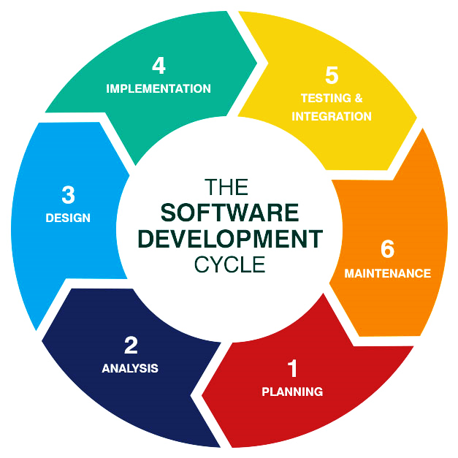

**Figure 2.1: Software Development Life Cycle**

**Feasibility Studies**

At first stage of SDLC we have to measure feasibility study of our proposed system that is system feasibility study of economics, implementation etc.

**Requirement Definition**

Requirement definition is the user-oriented description of what the system needs to perform. This also defines the abstract description of the services that the system should give and the constraint under the system must perform.

Requirement definition is necessary for the external behavior of the system, not the internal design. This definition is expressed for the users who doesn’t have specialized knowledge about the system.

Requirement definition needs to be consistent and complete. It means all the basic services required by the users should be defined. And Requirement should not have contradictions.

**System Specification**

System Specification is the structured collection of information that defines the requirements of a system. In system specification, our first concern is ERD (Entity Relationship Diagram), which shows entity with each of their attributes and their relationship with entities involving one to one, one to many, many to one or many to many, assigning primary keys & perform normalizations to reduce data redundancy.

**System Design**

The process of translating between the systems specifications into the specification of how the system will apply it. System design is also a part of software configuration. It forms part of the project’s documentation. The person who designs the system must be careful while doing it or the system might get very complex. The designer should keep in mind some the factors like performance, ease of use, ease of maintenance, reliability etc.

**Programming**

Programming is the part where the main part of the software is being created. It is done using several suitable programming languages. But surprisingly the programming or coding part becomes much easier when previous stages are done properly. Coding is simply the translation of specification of the system design into the specification of program in a programming language.

**Testing**

This stage determines that the software fulfilled its specifications. By testing, a developer makes sure that the software is working as it should. And it doesn’t have any glitches or bugs.

Testing can be difficult based on the complexity of system specifications or user requirements. Sometimes for even small software, it becomes harder to test every combination of input and variable values. Though, good design and specification of test plans can reduce the effort. Simply, testing is the stage of finding errors. It doesn’t make sure there are no errors.

**Implementation**

Implementation is that stage where the coded software is implemented in the specific domain.

SOFTWARE REQUIREMENTS

**TECHNOLOGY USED**

**Software and Operating System:**

* Microsoft Windows 10 Pro
* Microsoft Visual Studio 2015
* Microsoft SQL Server 2012
* Microsoft Office 2016

**Technologies:**

* ASP.NET MVC 5
* HTML5
* CSS3
* JavaScript
* Entity Framework 6.1.3
* Ajax
* Some third-party add-ins

TABLE DEFINITION

**Entity: InstituteAdmin**

|  |  |  |  |
| --- | --- | --- | --- |
| Serial No: | Data Name | Data type | Constrain |
| 1 | InstituteAdminID | Int | PK, Not Null, Identity |
| 2 | InstituteAdminName | nvarchar(MAX) | Not null |
| 3 | InstituteName | nvarchar(MAX) | Not null |

**Entity: Feedback**

|  |  |  |  |
| --- | --- | --- | --- |
| Serial No: | Data Name | Data type | Constrain |
| 1 | FeedbackID | Int | PK, Not Null, Identity |
| 2 | FullName | nvarchar(MAX) | Not null |
| 3 | Email | nvarchar(MAX) | Not null |
| 4 | PhoneNumber | nvarchar(MAX) | Not null |
| 5 | Message | nvarchar(MAX) | Not null |
| 6 | FeedbackScale | nvarchar(MAX) | Not null |

**Entity: Registration**

|  |  |  |  |
| --- | --- | --- | --- |
| Serial No: | Data Name | Data type | Constrain |
| 1 | RegistrationID | Int | PK, Not Null, Identity |
| 2 | ExamineeId | Int | FK (Examinee), Not null |
| 3 | TestID | Int | FK (Test), Not null |
| 4 | RegistrationDate | Datetime | Not null |
| 5 | Token | nvarchar(MAX) | Not null |
| 6 | TokenExpireDate | Datetime | Not null |

**Entity: Examiner**

|  |  |  |  |
| --- | --- | --- | --- |
| Serial No: | Data Name | Data type | Constrain |
| 1 | ExaminerID | Int | PK, Not Null, Identity |
| 2 | InstituteAdminID | Int | FK,Not null |
| 3 | UserName | nvarchar(MAX) | Not null |

**Entity: TestXQuestion**

|  |  |  |  |
| --- | --- | --- | --- |
| Serial No: | Data Name | Data type | Constrain |
| 1 | TestXQuestionID | Int | PK, Not Null, Identity |
| 2 | TestID | Int | FK (Test), Not null |
| 3 | QuestionID | Int | FK (Question), Not null |
| 4 | QuestionNumber | nvarchar(MAX) | Not null |

**Entity: TestXPaper**

|  |  |  |  |
| --- | --- | --- | --- |
| Serial No: | Data Name | Data type | Constrain |
| 1 | TestXPaperID | Int | PK, Not Null, Identity |
| 2 | ChoiceID | Int | FK (Choice), Not null |
| 3 | RegistrationID | Int | FK (Registration), Not null |
| 4 | TextXQuestionID | Int | FK (TestXQuestion), Not null |
| 5 | Answer | nvarchar(MAX) | Null |
| 6 | MarkScored | Decimal(18,2) | Not Null |

**Entity: Test**

|  |  |  |  |
| --- | --- | --- | --- |
| Serial No: | Data Name | Data type | Constrain |
| 1 | TestID | Int | PK, Not Null, Identity |
| 2 | Name | nvarchar(MAX) | Not null, |
| 3 | Description | nvarchar(MAX) | Not null |
| 4 | IsActive | nvarchar(MAX) | Not null |
| 5 | DurationInMinute | nvarchar(MAX) | Not null |

**Entity: QuestionSetter**

b

|  |  |  |  |
| --- | --- | --- | --- |
| Serial No: | Data Name | Data type | Constrain |
| 1 | QuestionMakerID | Int | PK, Not Null, Identity |
| 2 | QuestionMakerName | nvarchar(MAX) | Not null |

**Entity: Question**

|  |  |  |  |
| --- | --- | --- | --- |
| Serial No: | Data Name | Data type | Constrain |
| 1 | QuestionID | Int | PK, Not Null, Identity |
| 2 | QuestionCategoryID | Int | FK (QuestionCategory), Not null |
| 3 | QuestionMakerID | Int | FK (QuestionMaker), Not null |
| 4 | QuestionType | nvarchar(MAX) | Not Null |
| 5 | MainQuestion | nvarchar(MAX) | Not Null |
| 6 | Points | Int | Not Null |
| 7 | IsActive | BIT | Not Null |

**Entity: QuestionCategory**

|  |  |  |  |
| --- | --- | --- | --- |
| Serial No: | Data Name | Data type | Constrain |
| 1 | QuestionCategoryID | Int | PK, Not Null, Identity |
| 2 | Category | nvarchar(MAX) | Not null |

**Entity: Choice**

|  |  |  |  |
| --- | --- | --- | --- |
| Serial No: | Data Name | Data type | Constrain |
| 1 | ChoiceID | Int | PK, Not Null, Identity |
| 2 | QuestionID | Int | FK (Question), Not null |
| 3 | Label | nvarchar(MAX) | Not null |
| 4 | Points | Int | Not null |
| 5 | IsActive | BIT | Not null |

**Entity: Examinee**

|  |  |  |  |
| --- | --- | --- | --- |
| Serial No: | Data Name | Data type | Constrain |
| 1 | ExamineeID | Int | PK, Not Null, Identity |
| 2 | DOB | Datetime | Not null |
| 3 | Address | nvarchar(MAX) | Not null |
| 4 | Email | nvarchar(MAX) | Not Null |
| 5 | Name | nvarchar(MAX) | Not Null |
| 6 | EntryDate | Datetime | Not Null |
| 7 | Phone | nvarchar(MAX) | Not Null |

**Entity: ExamAudit**

**[Don’t required manual record entry. It depends on the user’s action.]**

|  |  |  |  |
| --- | --- | --- | --- |
| Serial No: | Data Name | Data type | Constrain |
| 1 | ExamAuditID | Int | PK, Not Null, Identity |
| 2 | TableName | nvarchar(MAX) | Not null |
| 3 | ModifiedBy | nvarchar(MAX) | Not null |
| 4 | Action | nvarchar(MAX) | Not Null |
| 5 | Date | Datetime | Not Null |

**DESIGN MODEL**

FLOWCHART

ONLINE EXAM SYSTEM FULL FLOWCHART

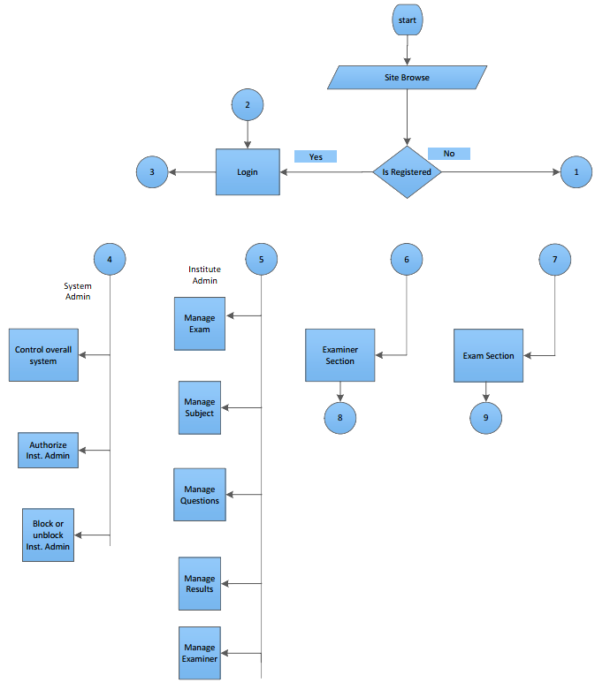

FLOW CHART

ONLINE EXAM SYSTEM REGISTRATION & EXAMINER & EXAMINEE

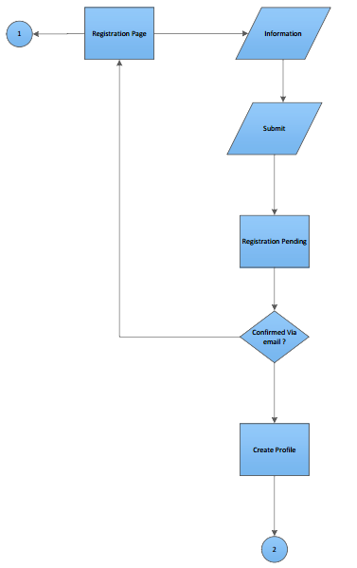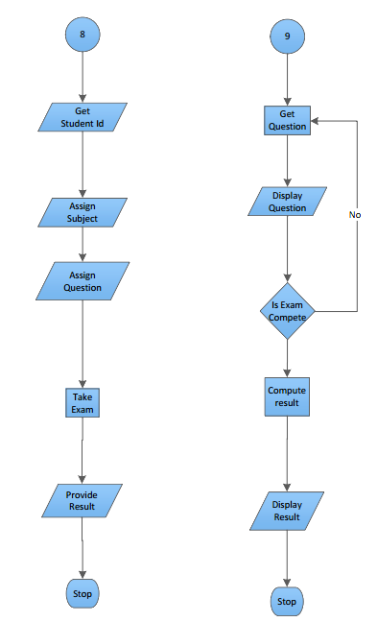

FLOW CHART

ONLINE EXAM SYSTEM LOGIN FLOW CHART

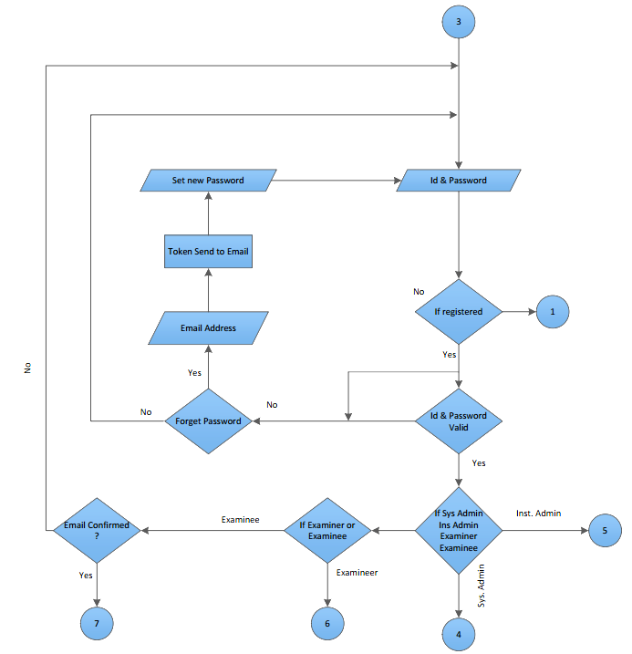

USE CASE

Use Case of Online Exam System

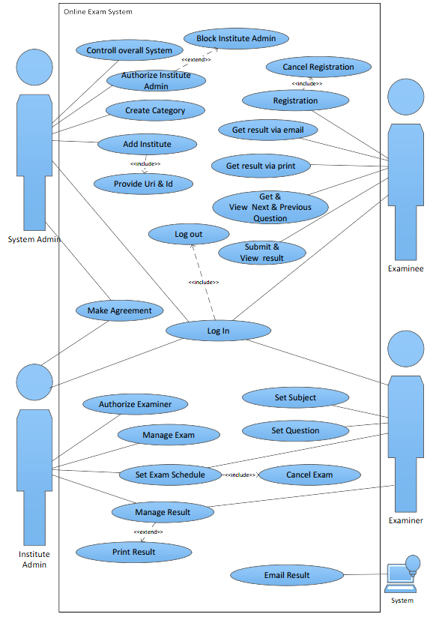

DATA FLOW DIAGRAM

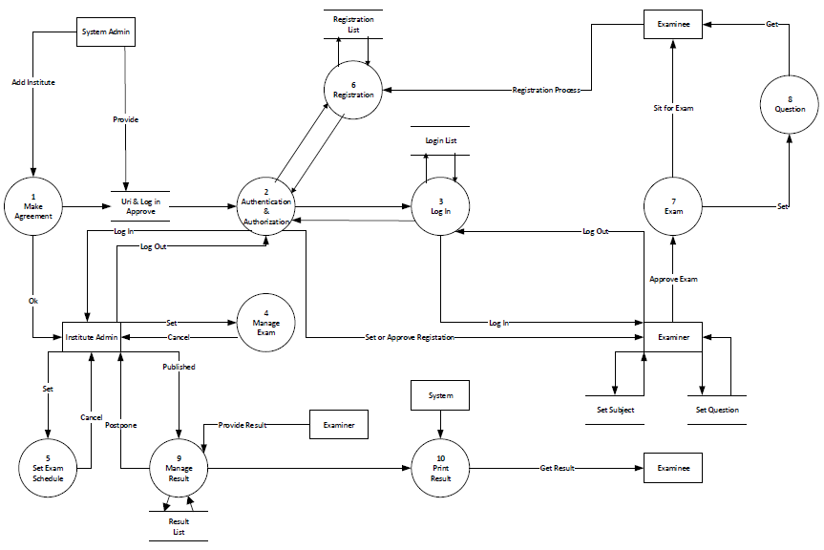

Figure: Data Flow Diagram of Online Exam System

CLASS DIAGRAM

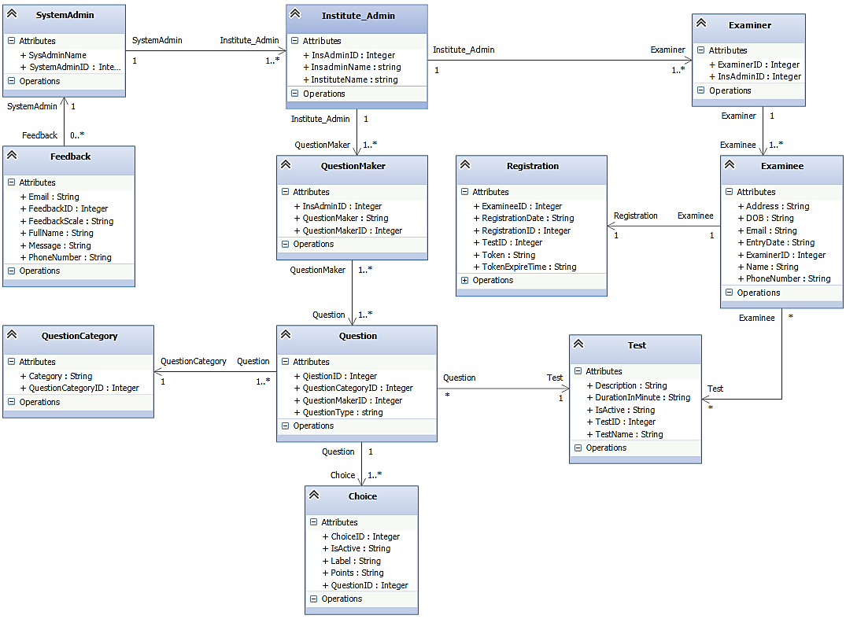

Figure: Class Diagram of Online Exam System

**CODE SAMPLE**

QUESTION SETTER MODEL CLASS

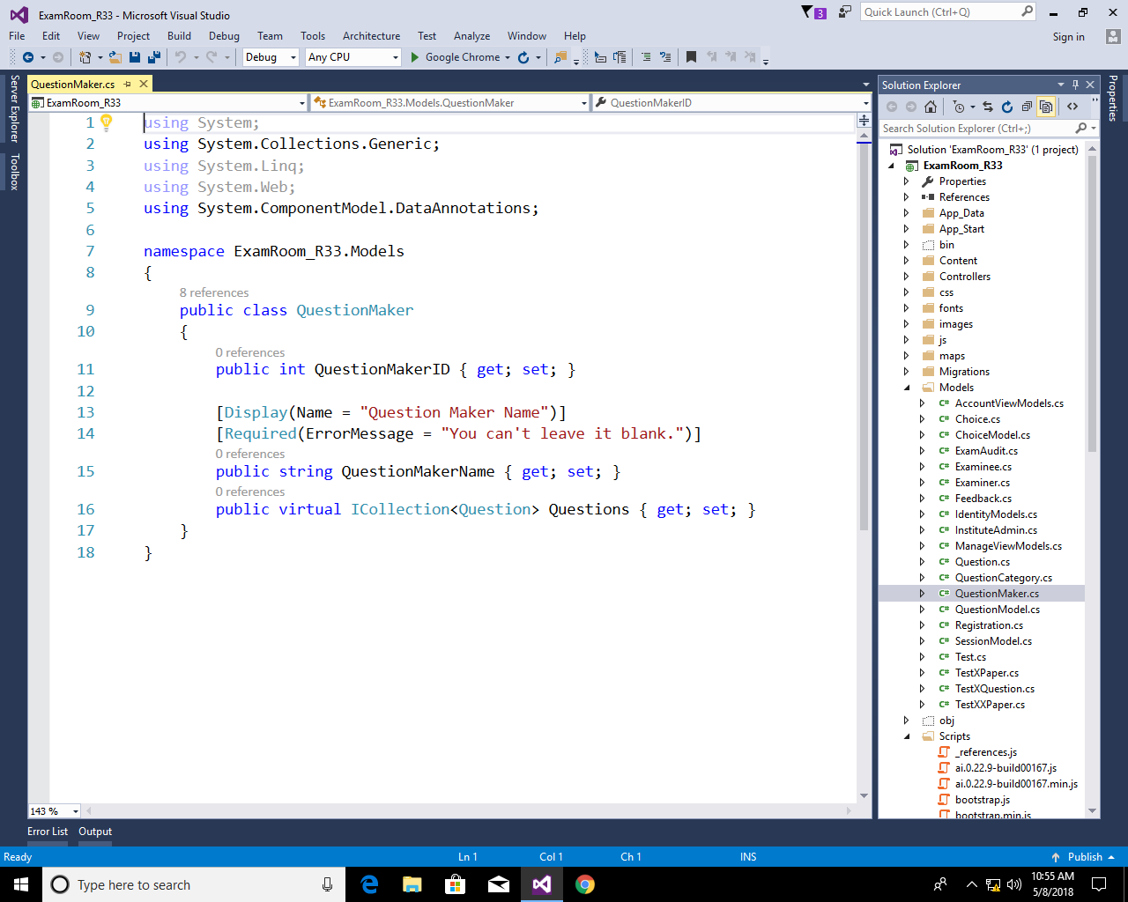

TEST MODEL CLASS

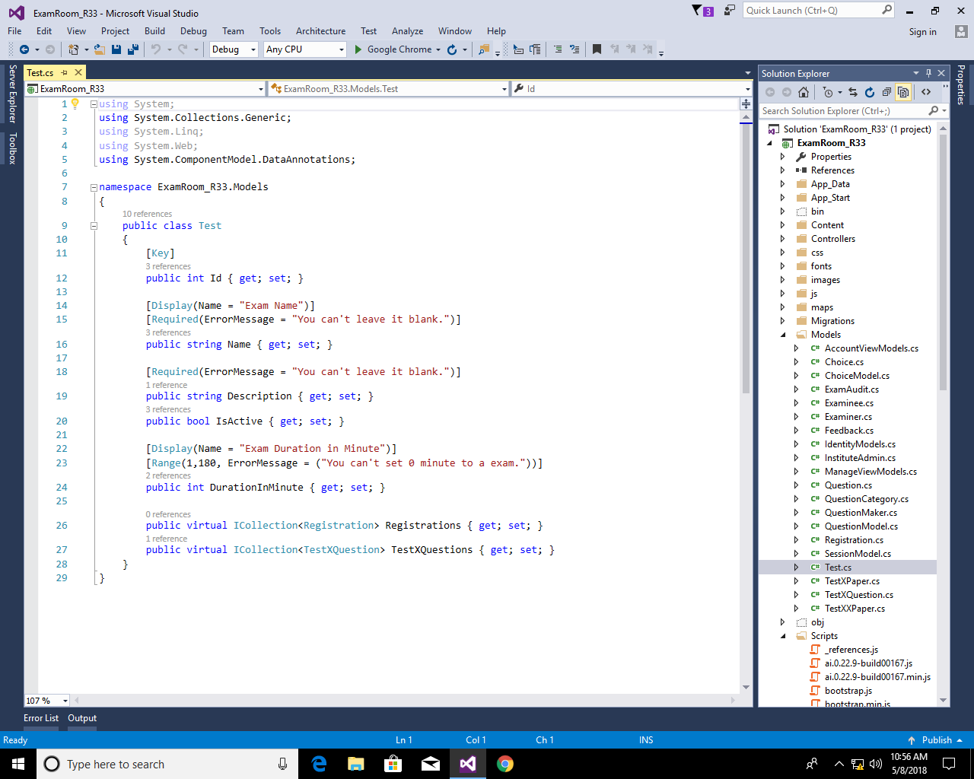

QUESTION SETTER CONTROLLER

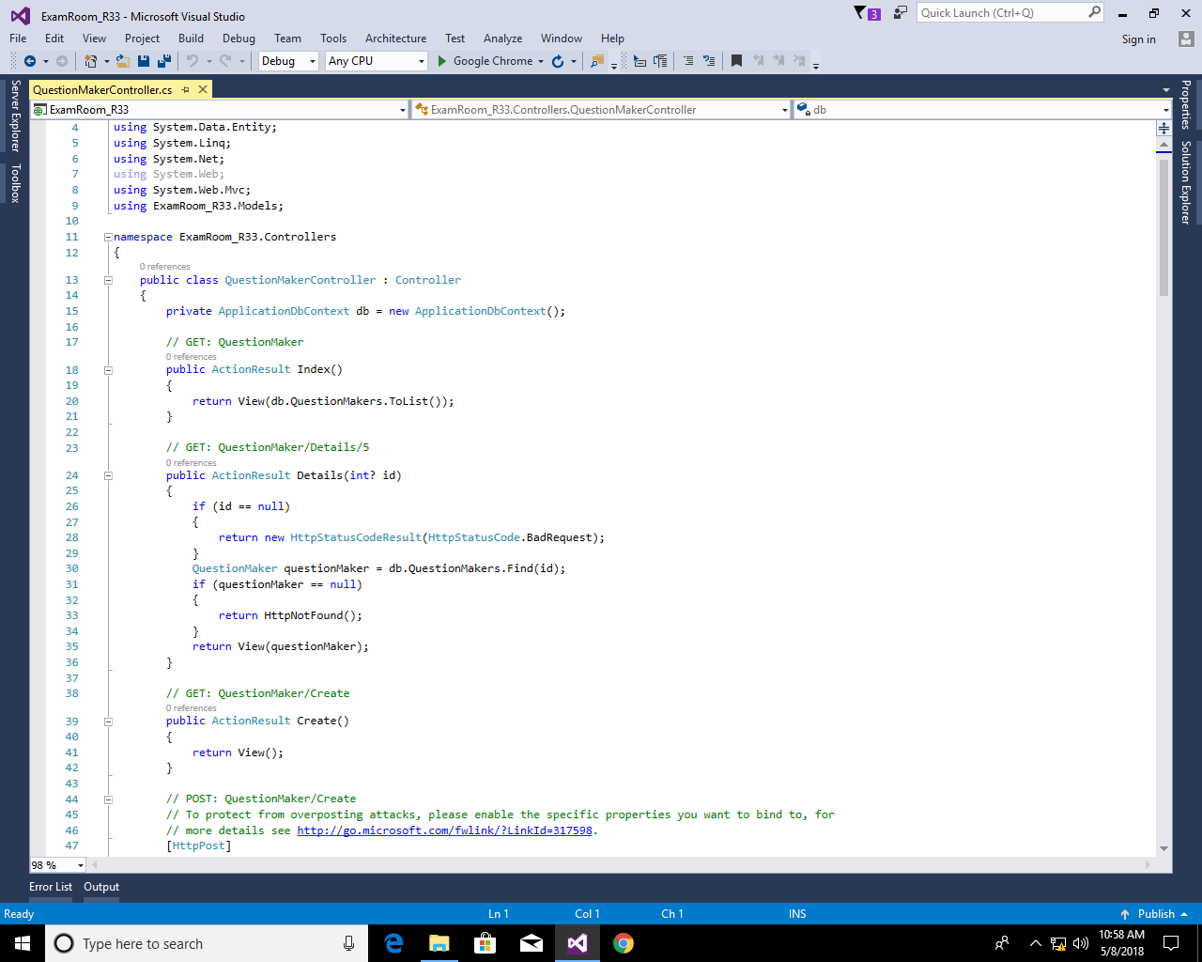

TEST CONTROLLER

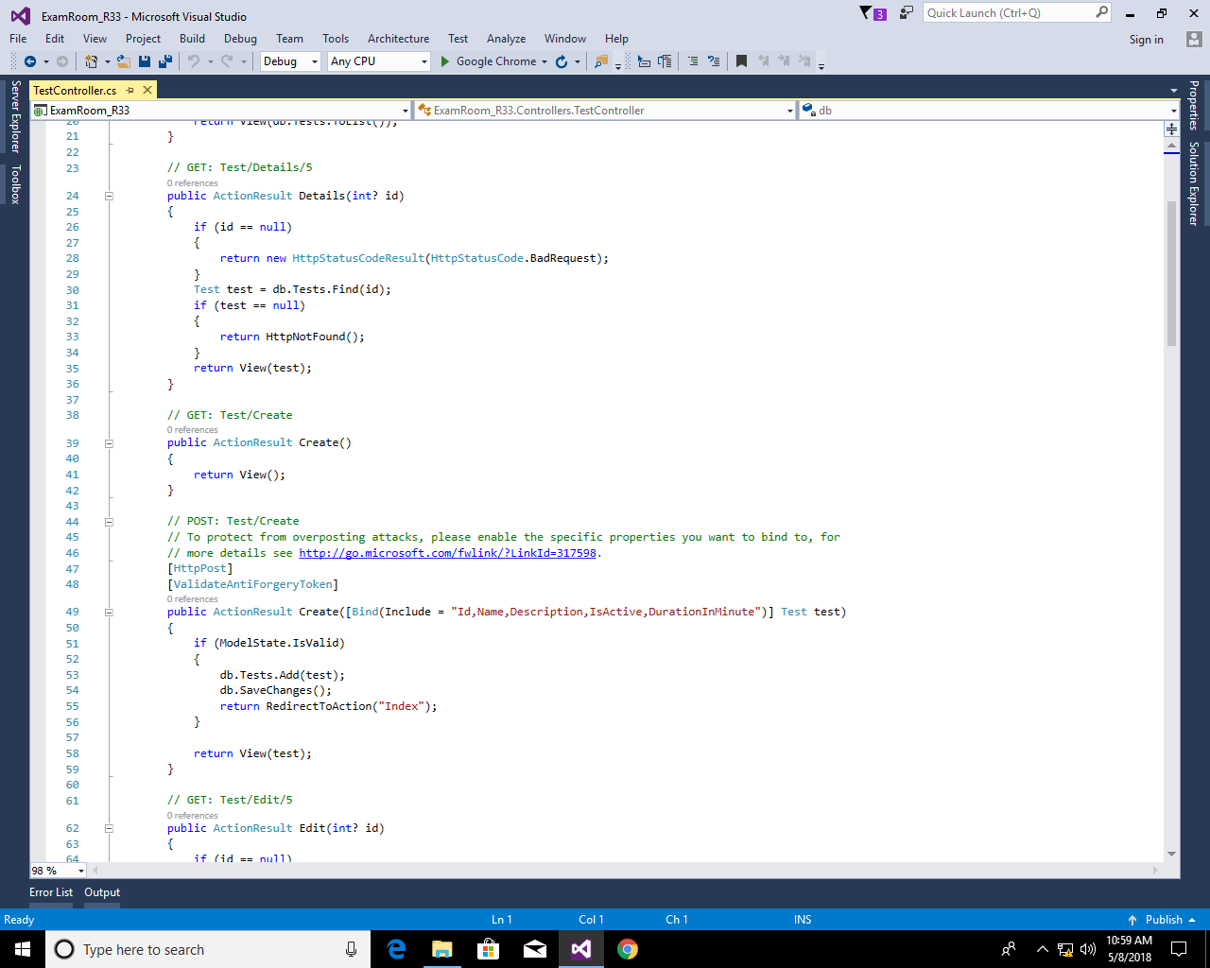

**USER INTERFACE SNAPSHOTS**

APPLICATION HOME PAGE



FOR ANONYMOUS USER

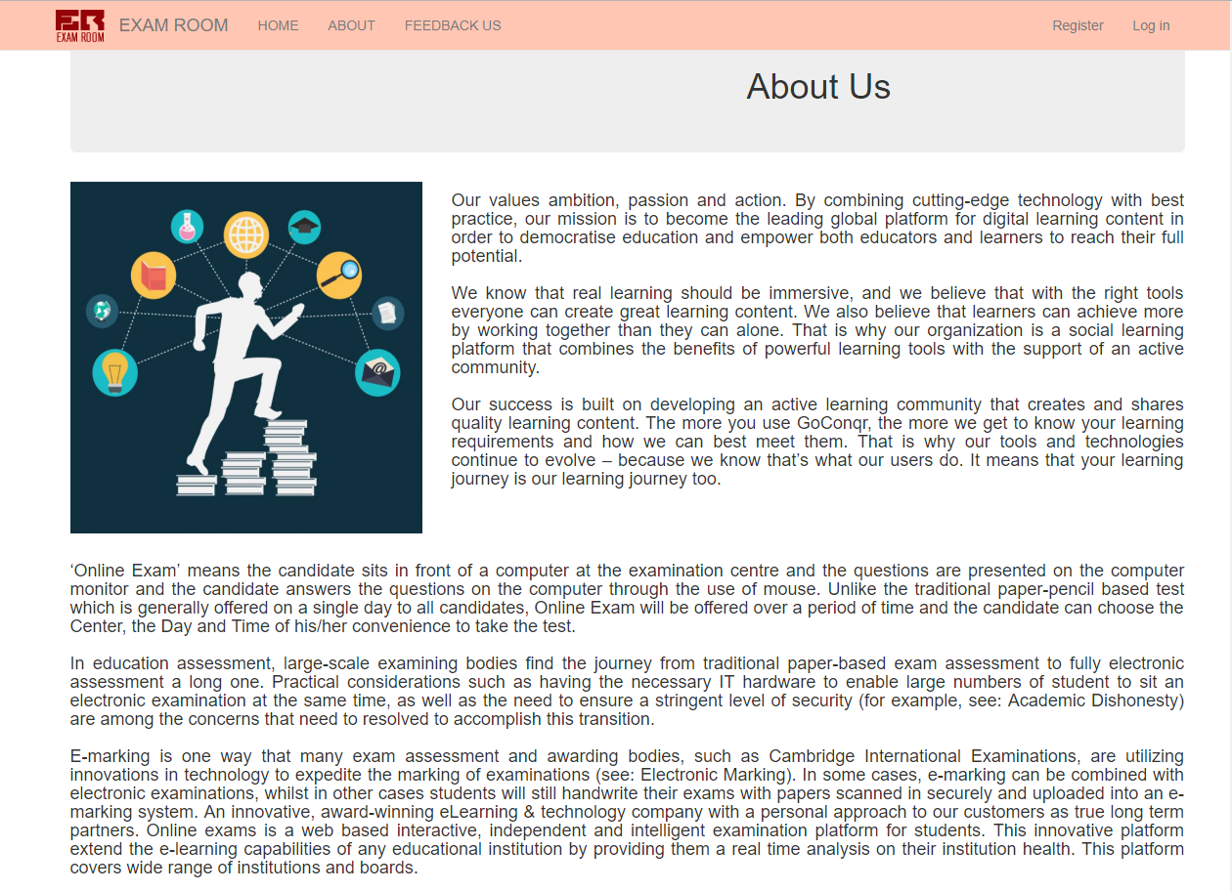

ANONYMOUS USER’S FEEDBACK

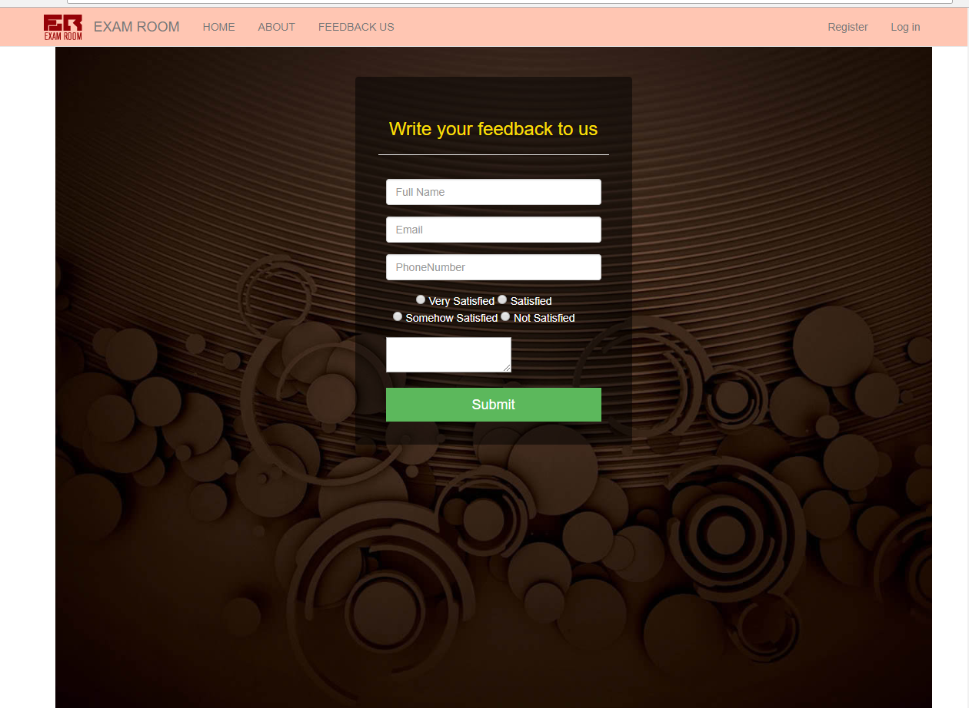

SYSTEM ADMIN LOGIN

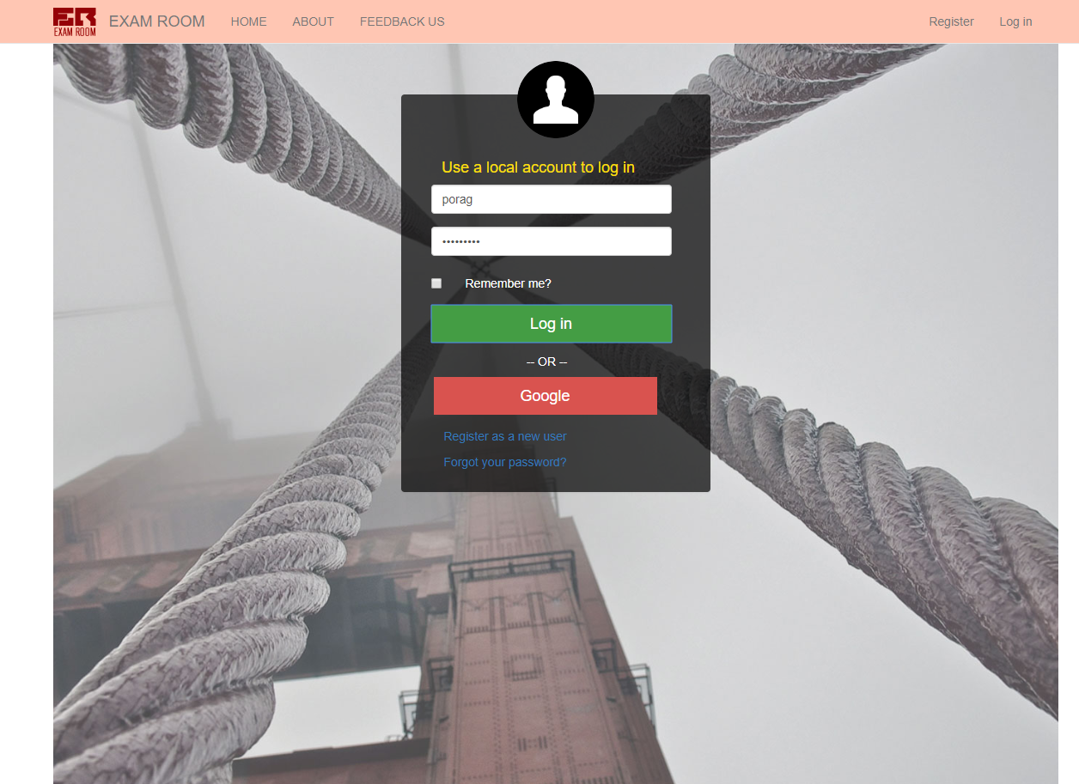

SYSTEM ADMIN DASHBOARD

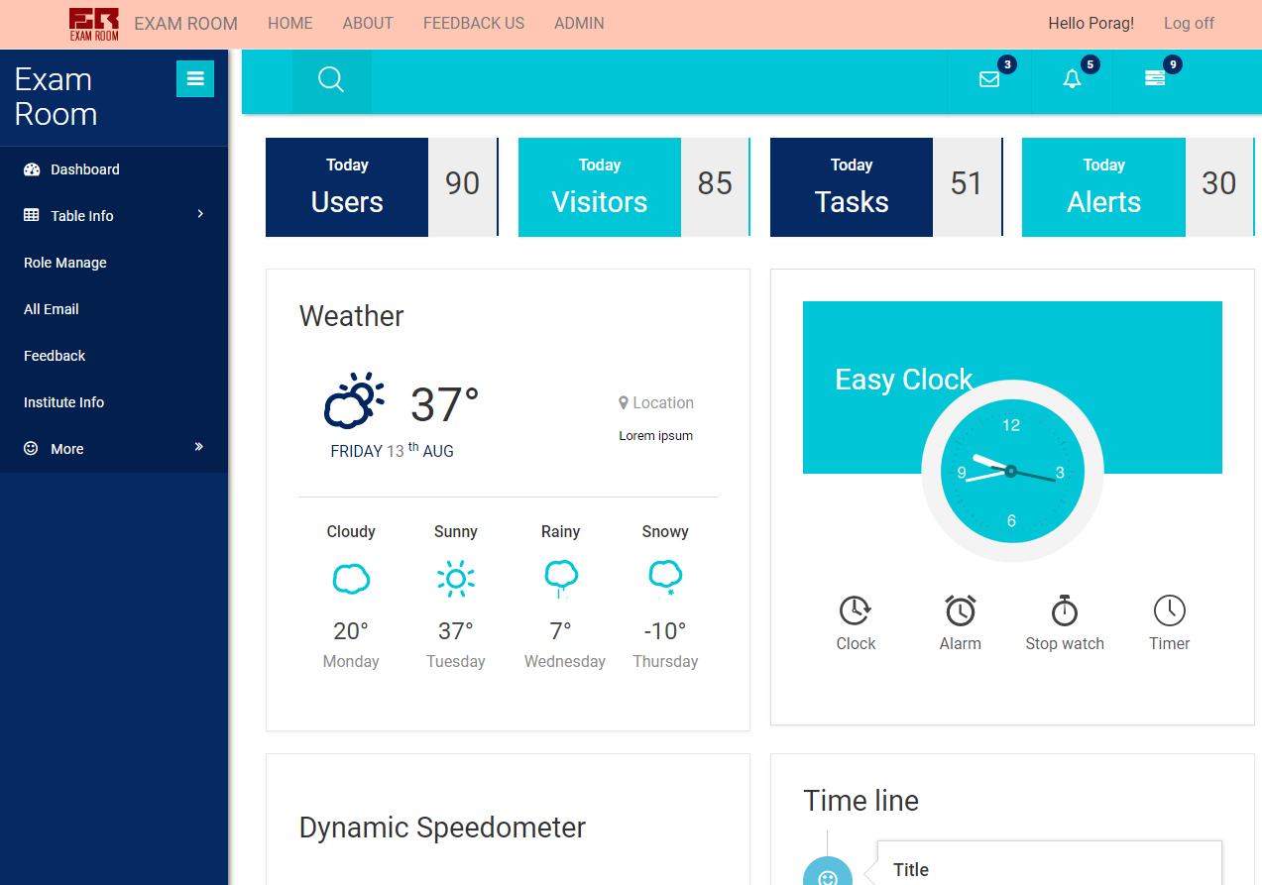

ROLE MANAGEMENT

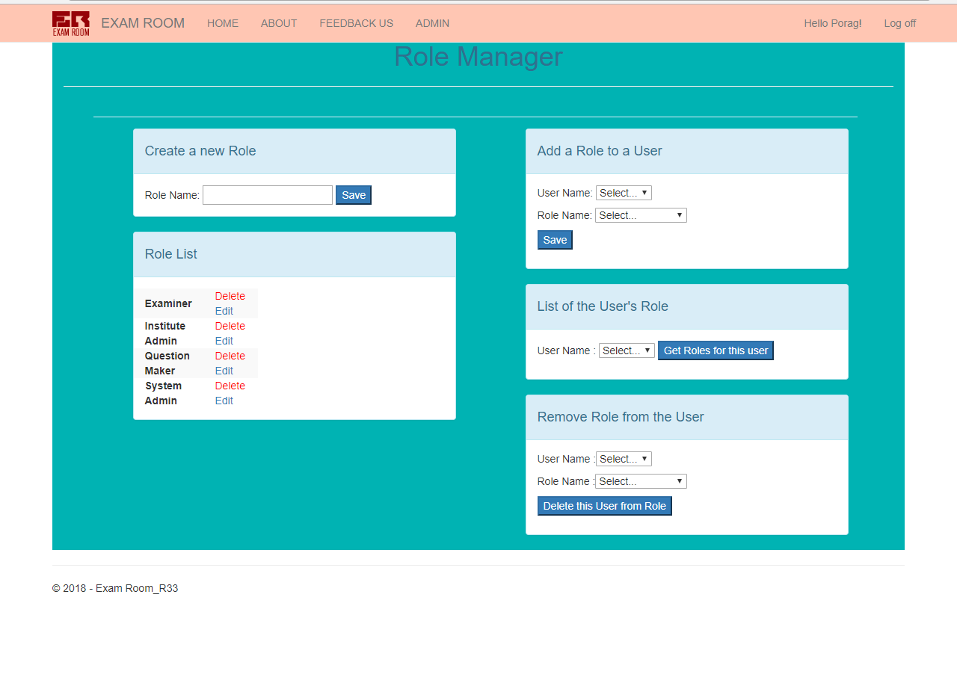

INSTITUTE ADMIN LOGIN

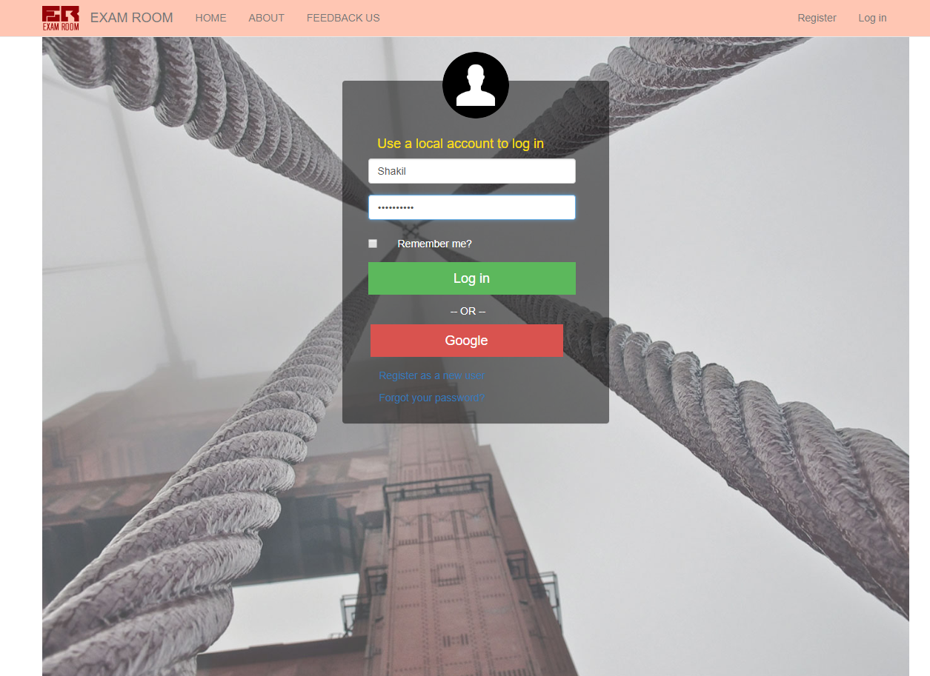

INSTITUTE ADMIN DASHBOARD

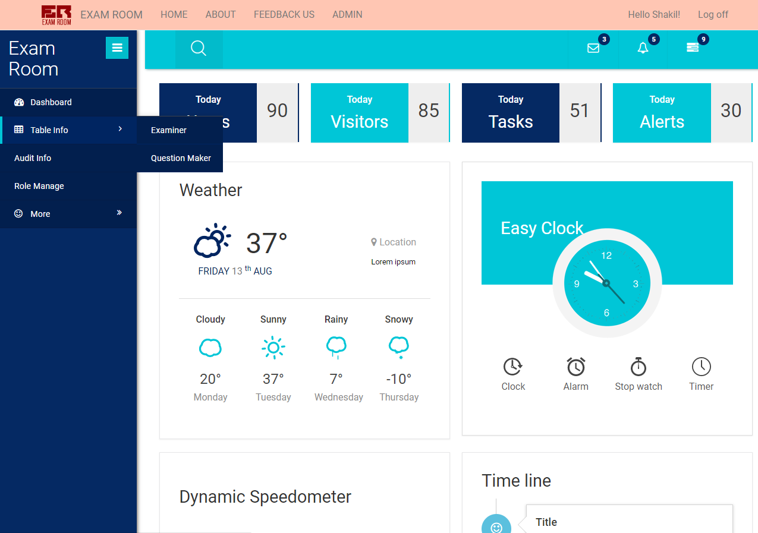

QUESTION SETTER LOGIN

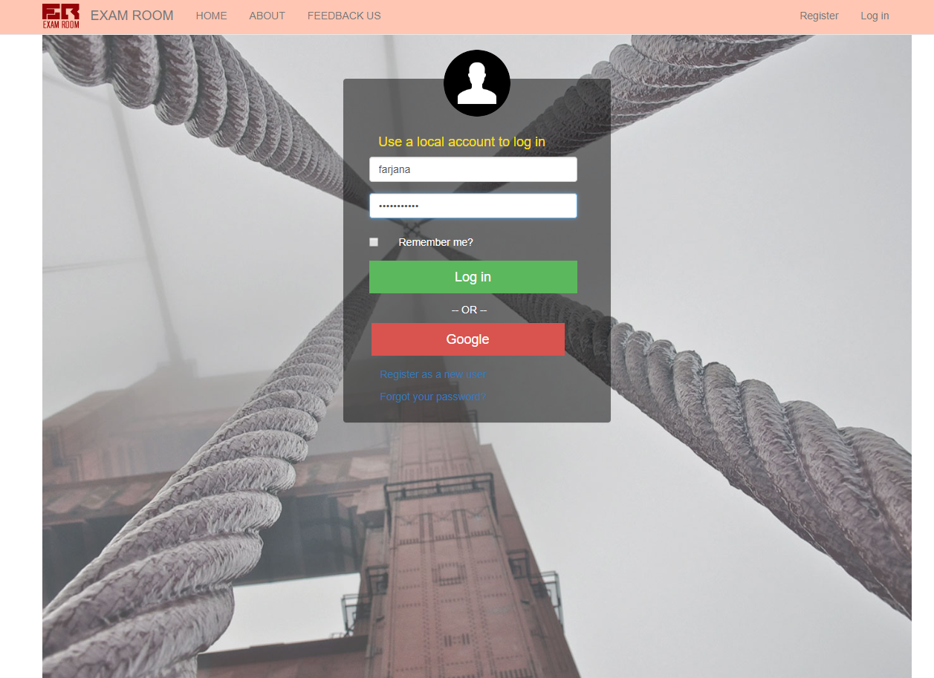

QUESTION SETTER DASHBOARD

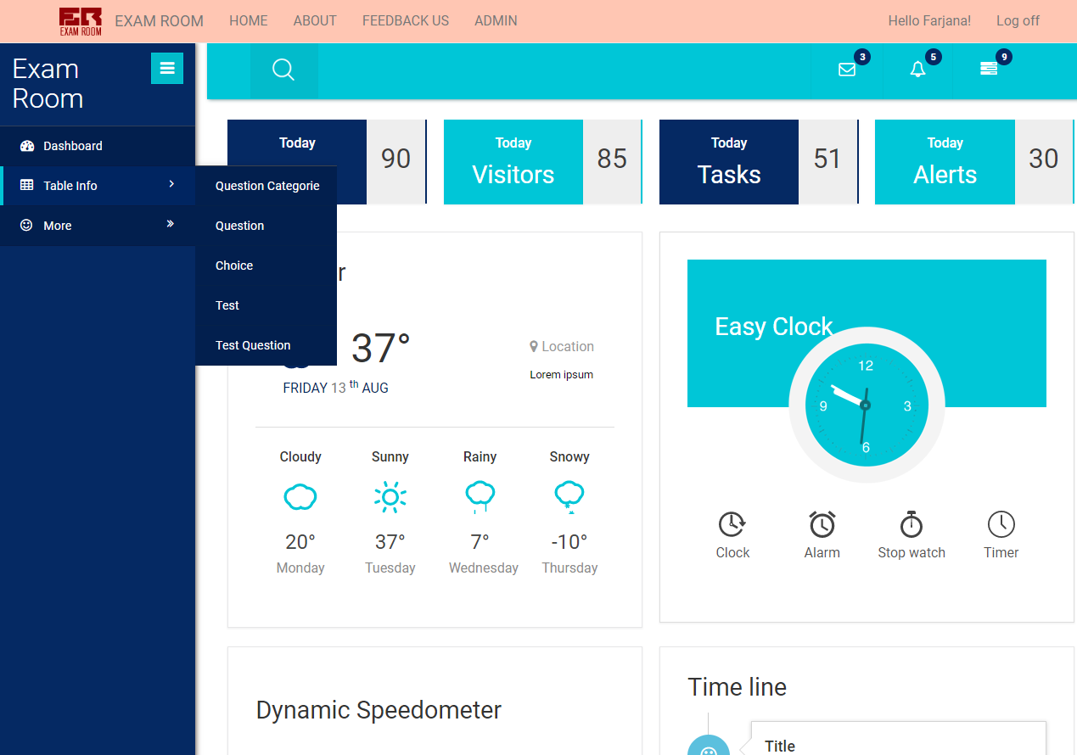

EXAMINER LOGIN

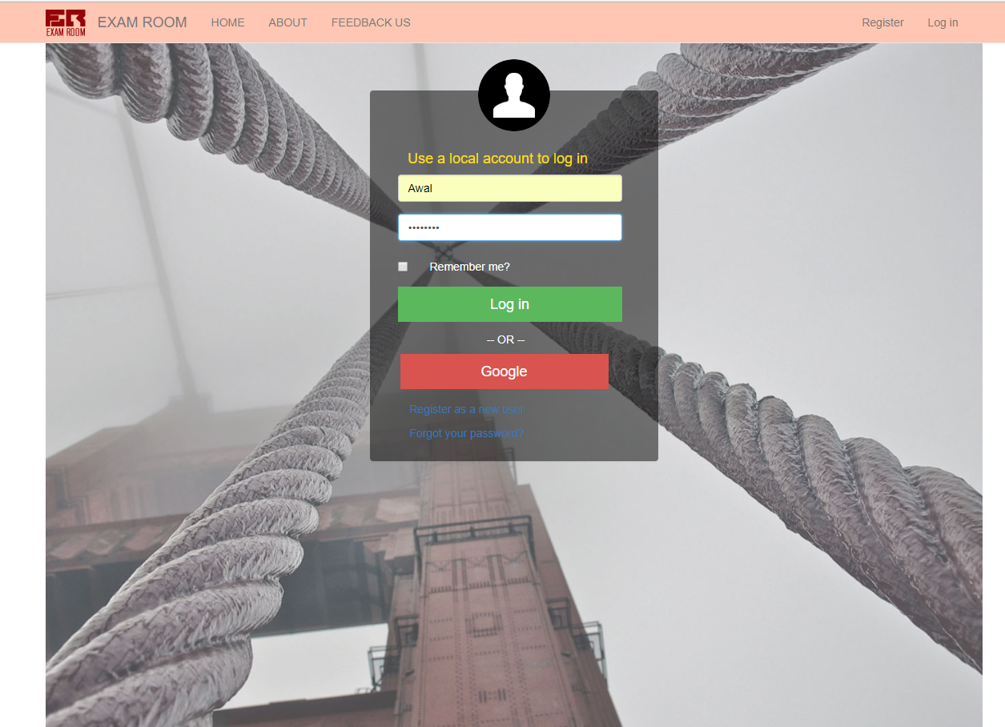

EXAMINER DASHBOARD

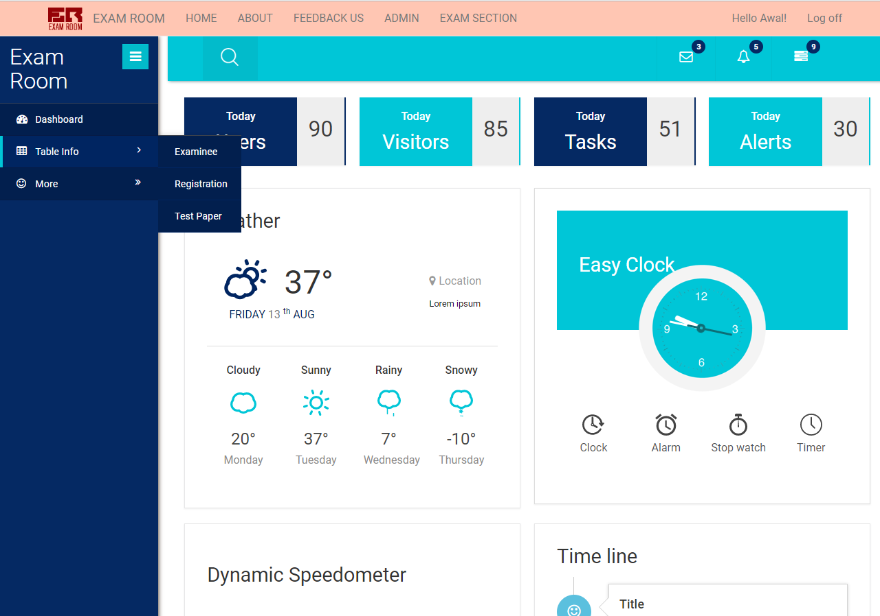

EXAMINEE’S REGISTRATION TO START THE EXAM

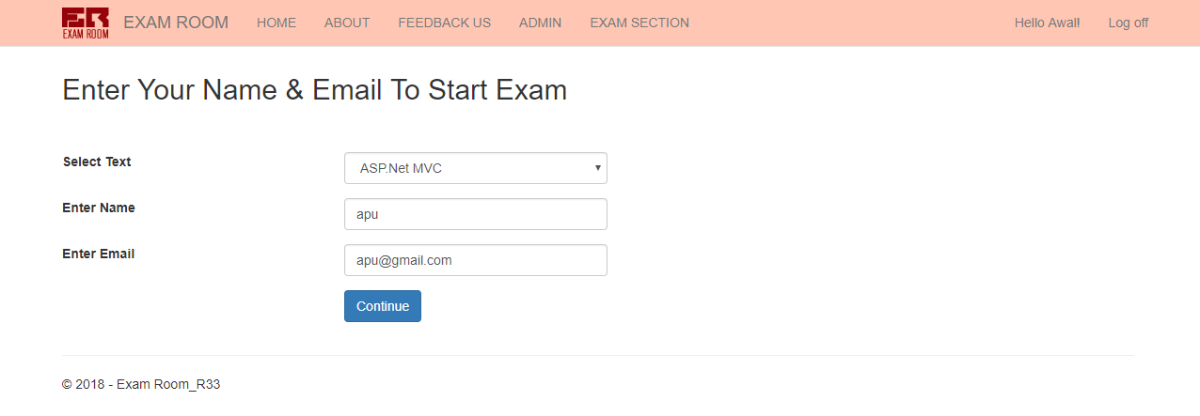

EXAM INSTRUCTIONS

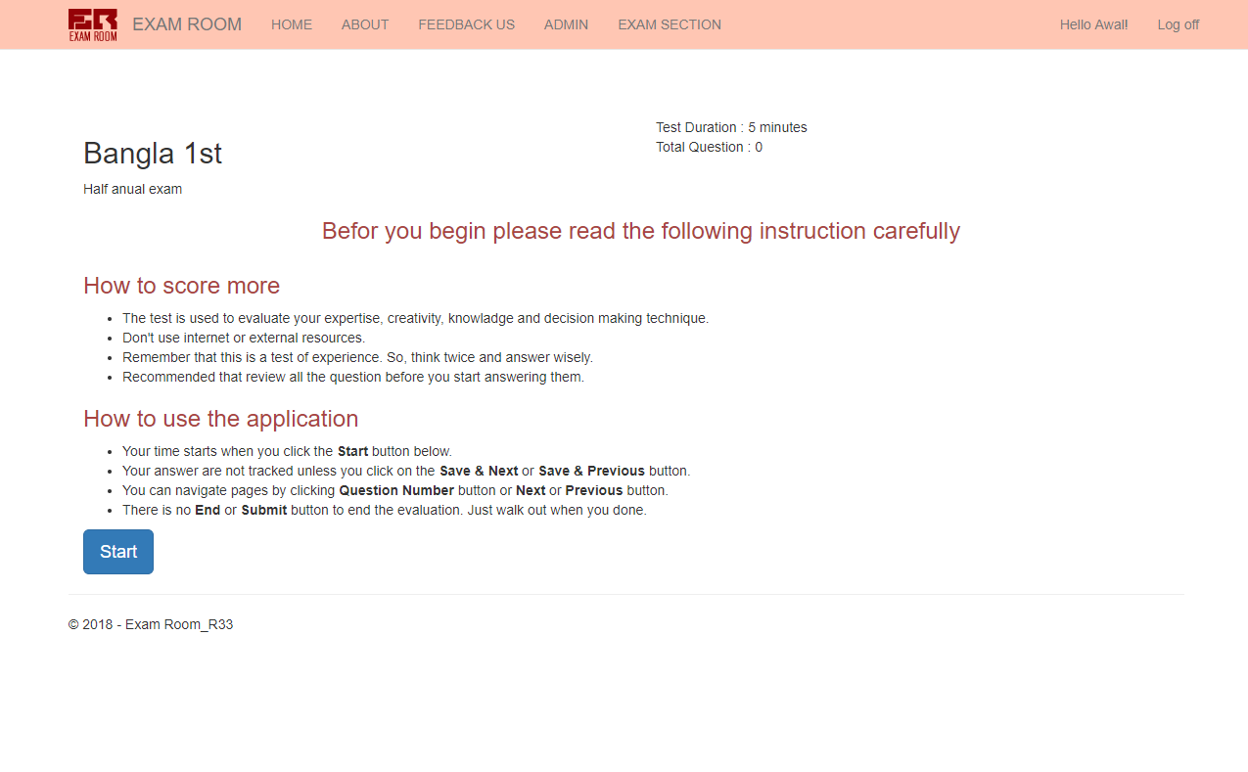

START EXAM

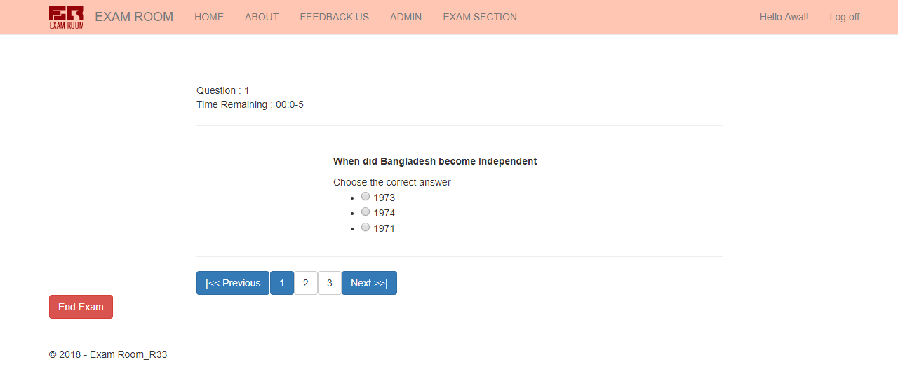

AFTER TIME OUT

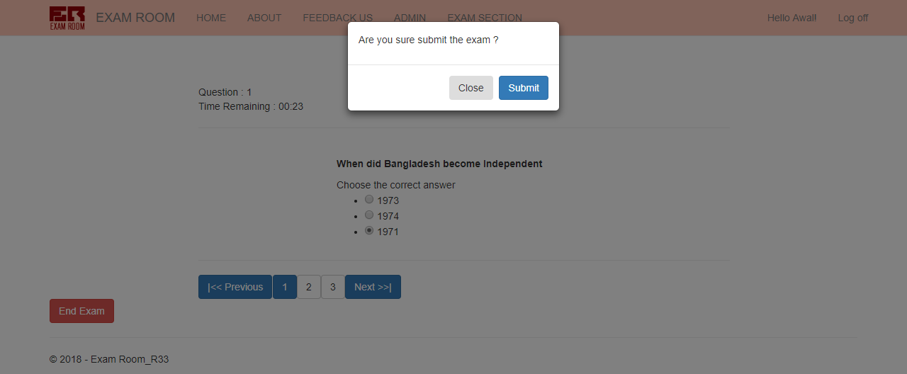

IF PASSED

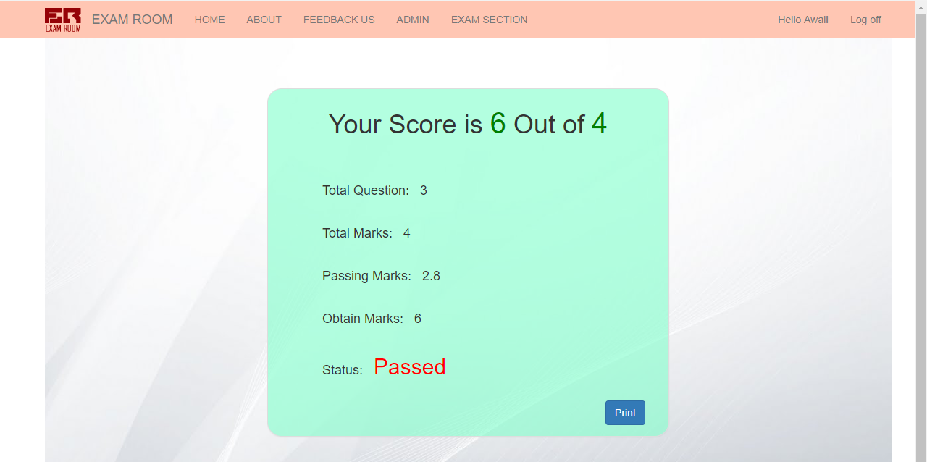

IF FAILED

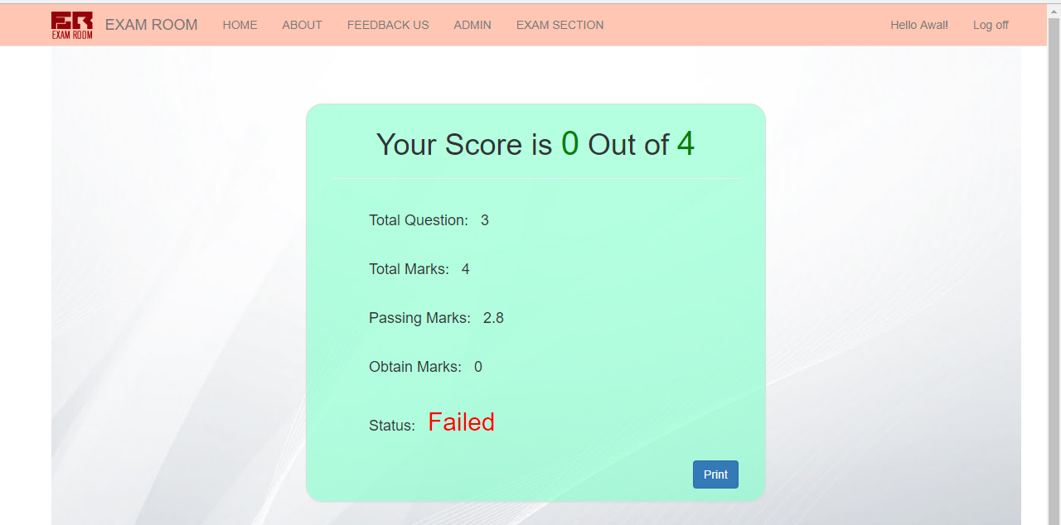

**CONCLUSION**

Online exam system is a nonremovable examination pattern of today’s life. We need more time saving and more accurate examination system as the number of applicants is increasing day by day. For all IT students and professionals, it is very important to have some basic understanding about the online examination system.

Its cost is under the budget and make within given time period. It is desirable to aim for a system with a minimum cost subject to the condition that it must satisfy all the requirement can be rectified easily.

Online Examination is being launched because a need for a destination that is beneficial for both Institutes and Examinees.With this site, institutes can register and host online exams. Examinees can give exams and view their results. This site is an attempt to remove the existing flaws in the manual system of conducting exams . The project will enable educational institutes to conduct test and have automated checking of answers based on the response by the examinees.

In our proposed portion, which we have kept pending, in future it will be applied in our project. For a short-time duration, we cannot complete our project, few things we have kept in our proposed. In future, it will be complete.

THANK YOU